Bahria University,

Karachi Campus



**2**

LIST OF TASKS

|  |  |
| --- | --- |
| TASK NO | OBJECTIVE |
| 1 | Write a Function to capitalize the first and last letters of each word that is input |
| 2 | Write a function to find common values within two lists and append in new list named "common_items". Use List comprehension for this |
| 3 | . write code for the task that will take user input of names of three students, along with marks of three courses . Calculate Marks obtained, Percentage and grade of each student. Append obt marks, percentage and grade in the list |
| 4 | On the basis of employees list mentioned above calculate average age of first two employees and insert that age in next two employees |
| 5 | using the employees list mention gender wise count of employees |

Submitted On:

29-Sep-2023

(Date: DD/MM/YYYY)

**LAB 02 LISTS SETS DICTIONARY TUPLES**

1. Write a Function to capitalize the first and last letters of each word that is input

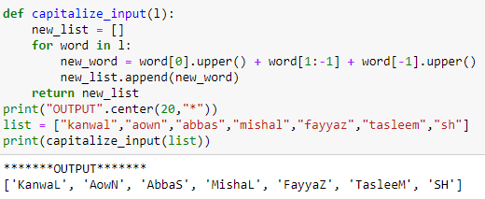

1. Write a function to find common values within two lists and append in new list named "common_items". Use List comprehension for this

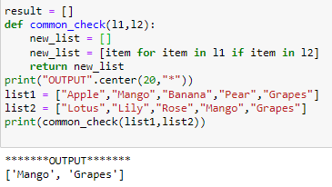

1. On the basis of employees list mentioned above calculate average age of first two employees and insert that age in next two employees.

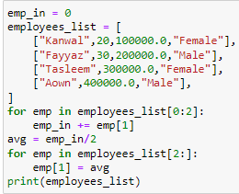



1. write code for the task that will take user input of names of three students, along with marks of three courses . Calculate Marks obtained, Percentage and grade of each student. Append obt marks, percentage and grade in the list

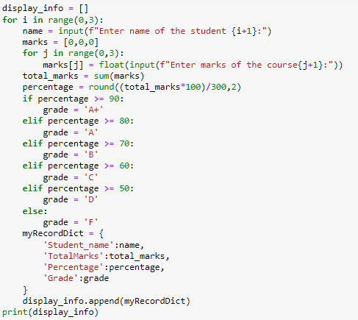

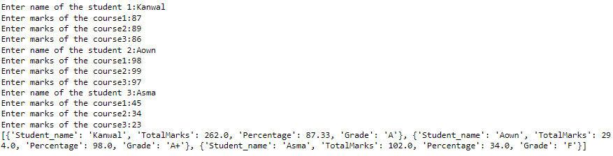

1. using the employees list mention gender wise count of employees

